Accessing Reports from the SAS Add In from Microsoft Excel:

Open Microsoft Excel and single-click the “SAS” tab.

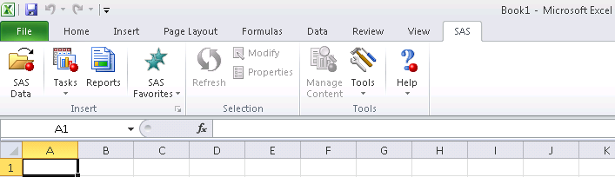

Select Reports

When prompted for a User name and Password, enter the User name and Password you use to access your computer (your network ID and password), then click “OK”.

If you need assistance with logging in, please send an email to DWHELP@valenciacollege.edu.

After you log in, the screen below should appear.

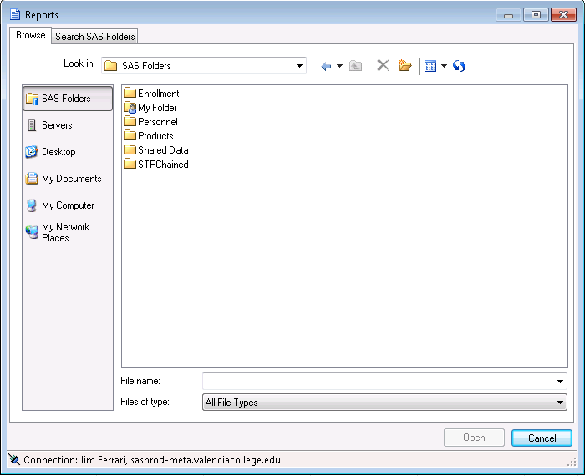

Double Click the folder of interest (available folders will vary depending on your role at Valencia). The example below uses the Enrollment folder.

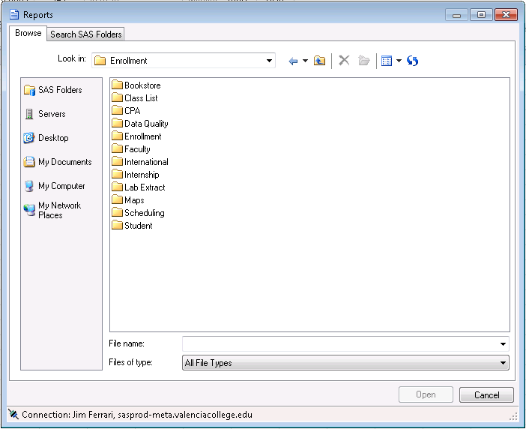

I selected the Enrollment folder again.

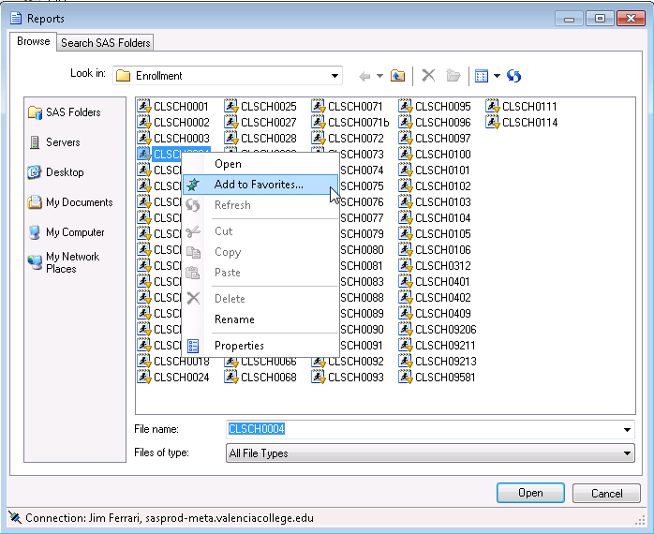

Right click on a folder to reveal a context menu and select “Add to Favorites…” to include the report in your Favorites.

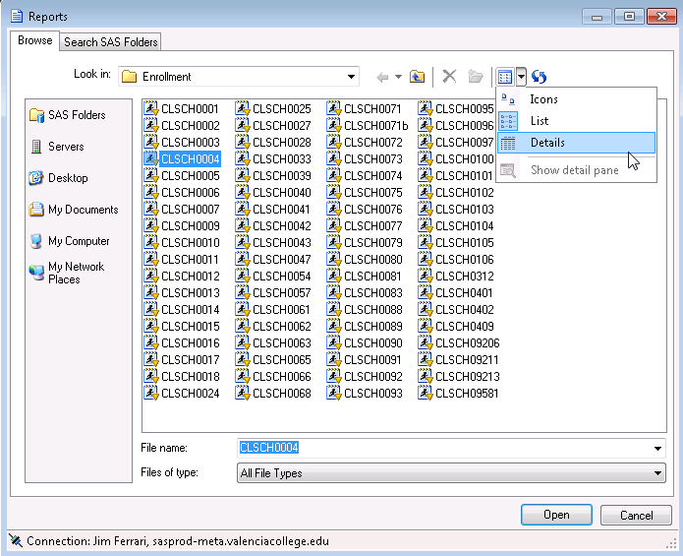

To add report description to the listing, click the down arrow next to the View icon and select “Details”.

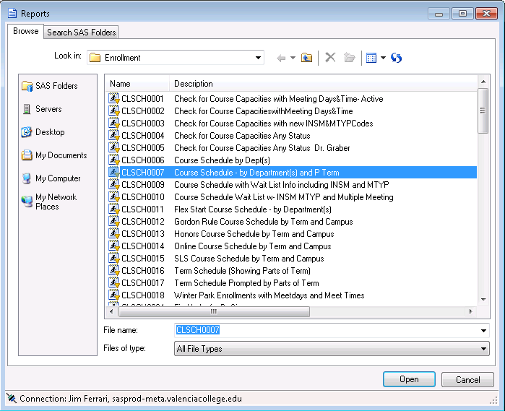

Double Click the report you want or Single Click and Click on Open. This will bring up a parameter window if the report has parameters.

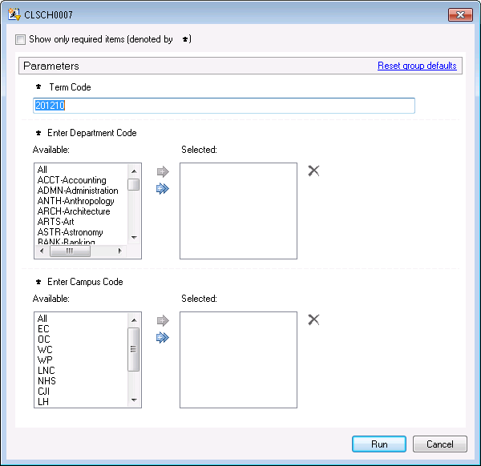

Type values in text fields like the Term Code. Select a single value from a pick list with a single Click or select multiple values by holding down the “Ctrl” key and clicking on multiple values. Use the arrows to move your selection from the “Available” box to the “Selected” box and then Click Run.

Make your selection where you want the results and click OK.

