Getting to the Data Warehouse Portal:

The SAS Information Delivery Portal website is located at:
http://valenciacollege.edu/DW

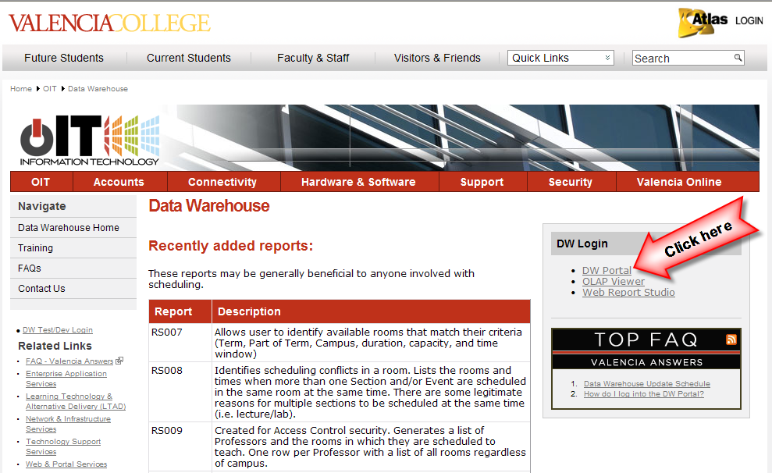

How to log onto the SAS Information Delivery Portal:

Type in your Network User ID and Password (the one you use to access your PC), then click the “Log On” button. If you are having problems with your User ID or password, please send an email to DWHELP@valenciacollege.edu.

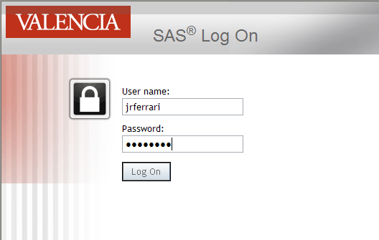

Click on the “Reports” tab to reveal the folder structure that organizes the reports.

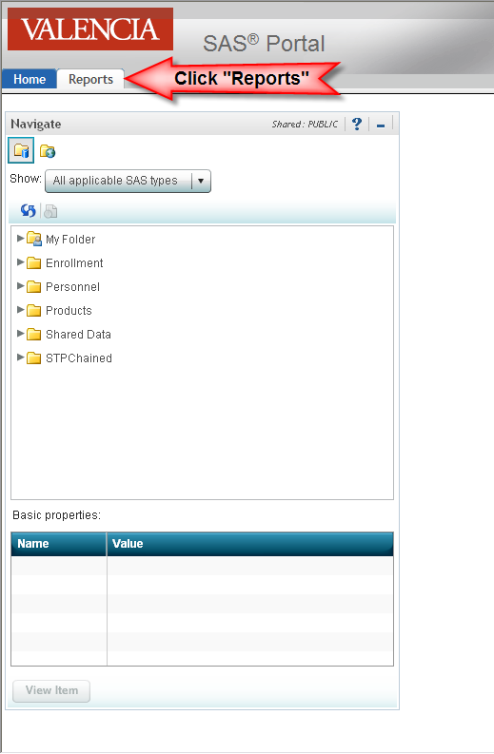
Drill down on the folder you want to access (Enrollment)

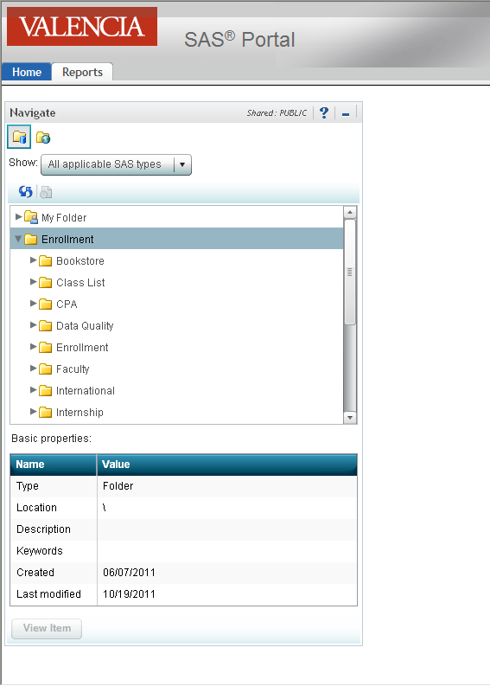

Scroll down to “Scheduling” and drill down.

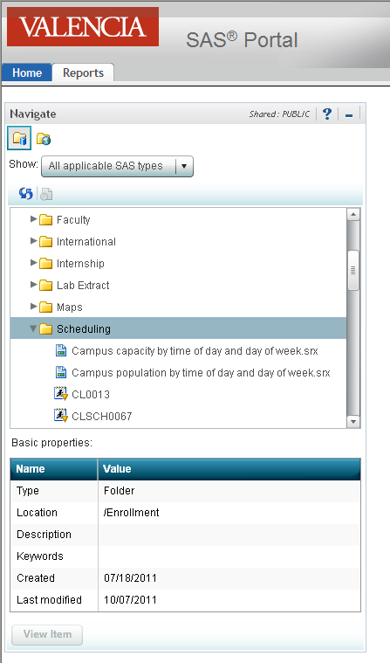

Scroll down and select RS013

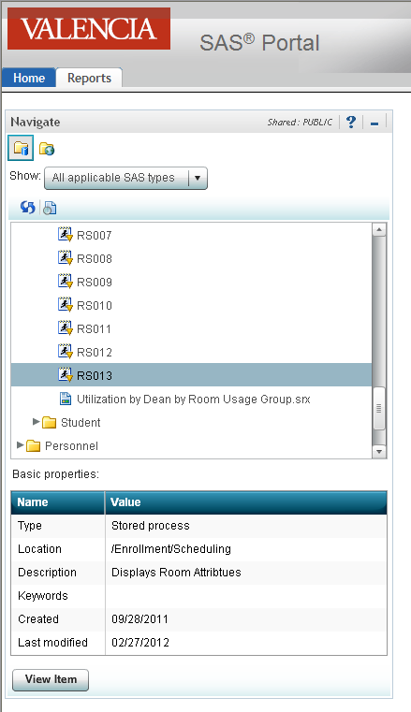

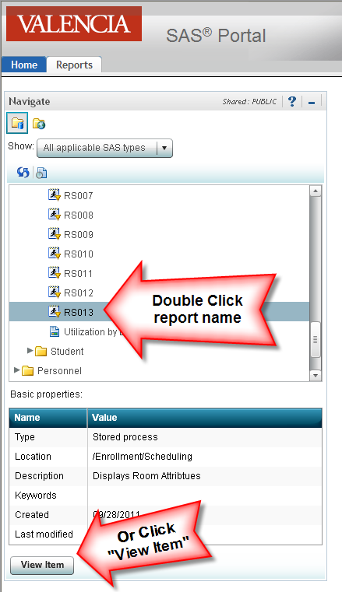

Populate parameters and click “Run”.

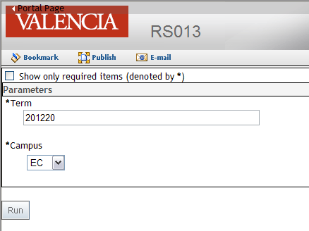

The output of the report is returned for viewing in your web browser.

